**Construct Binary Search Tree from Preorder Traversal**

Return the root node of a binary **search** tree that matches the given preorder traversal.

*(Recall that a binary search tree is a binary tree where for every node, any descendant of node.left has a value < node.val, and any descendant of node.right has a value > node.val.  Also recall that a preorder traversal displays the value of the node first, then traverses node.left, then traverses node.right.)*

It's guaranteed that for the given test cases there is always possible to find a binary search tree with the given requirements.

**Example 1:**

**Input:** [8,5,1,7,10,12]

**Output:** [8,5,10,1,7,null,12]

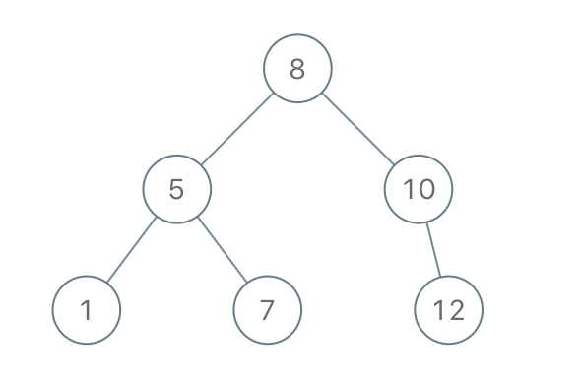

**Constraints:**

* 1 <= preorder.length <= 100
* 1 <= preorder[i] <= 10^8
* The values of preorder are distinct.